**EXP 4:-**Blinking led using HCO5 bluetooth receiver

**CIRCUIT DIAGRAM:-**

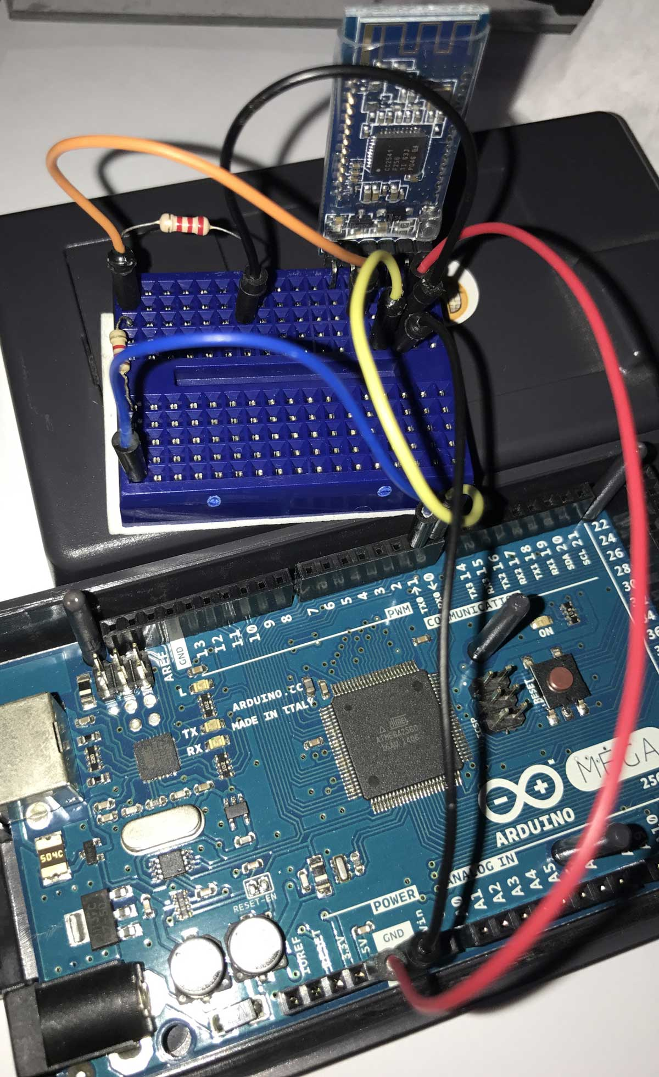

**REQUIREMENTS:-**

1.Breadboard

2.Arduino UNO

3.Connecting Wires

4.Bluetooth(HC05) receiver.

5.Resistor

6.LED

7. Smartphone

**THEORY:-**

1. Take an led and determine its positive and negative ends.
2. Install an app namely led controller on your android smartphone
3. Take a breadboard and determine the flow of current in breadboard.
4. Make the circuit as shown in the diagram.
5. Connect the Bluetooth receiver with your smartphone.
6. Write a code and upload it on Arduino

**CODE:-**

To upload code in Arduino,attach the Arduino with pc using usb cable

#define ledPin 13

int state = 0;

void setup() {

pinMode(ledPin, OUTPUT);

digitalWrite(ledPin, LOW);

Serial.begin(38400); // Default communication rate of the Bluetooth module

}

void loop() {

if(Serial.available() > 0){ // Checks whether data is comming from the serial port

state = Serial.read(); // Reads the data from the serial port

}

if (state == '0') {

digitalWrite(ledPin, LOW); // Turn LED OFF

Serial.println("LED: OFF"); // Send back, to the phone, the String "LED: ON"

state = 0;

} else if (state == '1') {

digitalWrite(ledPin, HIGH);

Serial.println("LED: ON");;

state = 0;

}

}

Precautions:-

1. Connections should be tight,there should not be any breakage.
2. LED should not be fuse.
3. Coding should be done properly

**TROUBLESHOOTING:-**

While connecting Bluetooth receiver with mobile phone,it was disconnecting again and again.

**LEARNING OUTCOMES:-**

ARDUINO UNO is an ATMEGA controller based board designed for electronic engineers . Arduino based program development environment is an easy way to write the program when compared to other environment development programs